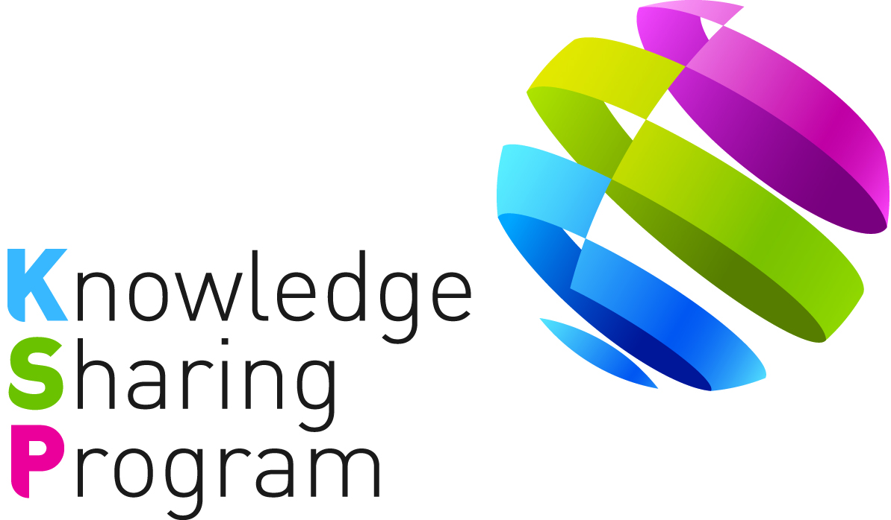

PROJECT CONCEPT PAPER
FOR
KNOWLEDGE SHARING PROGRAM

-Policy Consultation III-

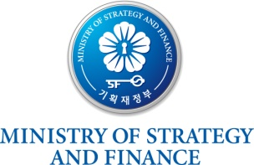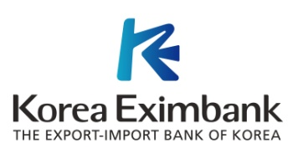

TABLE OF CONTENTS
I. Introduction 1
II. Key Issues 1
III. Project Overview 2
A. Impact & Outcome 2
B. Outputs 3
C. Activities & Methodologies 3
IV. Project Implementation Arrangement 4
A. Stakeholders 4
B. Work Division 4
C. Expected Schedule 5
D. Financing Plan 6
<Attachment 1> 7
<Attachment 2> 8
<Attachment 3> 11

<PROJECT CONEPT PAPER FOR THE 2016 KSP POLICY CONSULTING III>

Planning for the Modernization of Rail Transportation System in Yangon, Myanmar

Date: 31 August 2016

- Introduction

- In 2004, the Ministry of Strategy and Finance of Korea (“MoSF”) launched the Knowledge Sharing Program (“KSP”), a knowledge-based development and economic cooperation program designed to share experiences with partner countries. KSP Policy Consulting III is a government program designed to share Korea’s development know-hows and experiences with partner countries and provide comprehensive solutions covering policy consultation, development plan, and financing methods for projects related to urban and infrastructural development. In other words, the program aims to provide tailored policy consultation to partner countries by sharing Korean experiences and support the implementation of policy alternatives considering their current circumstances.

- Based on the request proposal submitted by the Government of Myanmar (“GoM”), the MoSF and the GoM agreed to implement “Planning for the modernization of rail transportation system in Yangon, Myanmar” (“the project”) in 2016 as one of the KSP Policy Consulting III projects. Under the supervision of the MoSF, the Export-Import bank of Korea (“Korea EXIMbank”) as a government agency for KSP prepared the project. The project impact, outcome, outputs, activities, implementation arrangements, and financing plans are based on consultation with the Myanmar Railway (“MR”) and Ministry of Transport and Communications (“MoTC”).

- Key Issues

- The Yangon circular line was built by the British 70 years ago and it carries around 75,000 to 130,000 people a day. However, poor infrastructure and management of the rail transport services are pushing away potential passengers as rail line serves only 2.18 million compared to the city’s population reached at 6 million. To examine the current railway industry in Myanmar, moreover, the quality of infrastructure is one of the least developed sectors as aging trains circumscribing the largest city of country meander through 39 stations at an average of 10 miles an hour.

- Train has remained an undesirable option for commuters due to the country coping hard with traffic congestion with overflows of vehicles. To fulfill the demands of passengers, the 153km (95-mile) circular rail line needs to be upgraded as well as reduce the congestion in urban transport system. However, GoM facing constraints for upgrading railway transport system due to insufficient investment in the core network and the lack of a modern commercially oriented financial management even though the better railway transportation is one of the priority projects proposed by the MR/MoTC. In addition, the barriers include lack of infrastructure, low budget, insufficient technical assistance, limited human resources, and skill shortages. The future development plans rely on mutually beneficial projects with other countries in this regard.
- Regarding the project, Korea has significantly succeeded cases of upgrading railway infrastructures and implementing improved transportation system including development of Light Rail Transit (“LRT”) and Mass Rapid Transit systems (“MRT”). Seoul Metropolitan Rapid Transit Corporation (“SMRT”) was established in 1994 to operate the Seoul Subway lines 5, 6, 7 and 8, and the rail transportation system in South Korea includes those main railway lines and rapid transit system in some major cities throughout the LRT and MRT projects as pursuing a low-cost, yet modern, high-quality, medium-capacity transit system to improve their transit services. Likewise railway systems of Korea have the advantages of being able to move masses of people efficiently, safely and in an environmentally-friendly manner around the city.

- Recently, the rail system in Korea includes a high speed rail, intercity rail, suburban rail and urban metro. Mostly, Seoul Metropolitan subway is one of the rapid railway transport systems in the world, featuring 10 subway lines. The system serves about 10 million inhabitants of the capital city, Seoul and provinces of Gyeonggi, Incheon and northern Chungnam. The lines are operated by four companies – Seoul Metropolitan Subway (Seoul Metro), Seoul Metropolitan Rapid Transit (SMRT), Korea National Railroad (Korail), and Metro 9. In addition, Seoul Metropolitan Government announced an ambitious plan to build seven new LRT systems by 2017 by Private Participation in Infrastructure (“PPI”). Particularly, LRT is a form of transportation that uses electric driven rail cars on rights-of–way and the term of light rail is used to distinguish it from conventional rail technologies such as high-speed, freight and metro/subway, which are considered as heavy rail. In Korea, it is generally refers to light rapid trains running on its separated rights-of-way, usually on elevated platforms (eg. Yongin LRT, Uijeongbu LRT and Busan-Gimhae LRT).

- Through this project, the comparison between LRT and MRT systems in the area of Yangon city to Hanthawaddy airport will be examined and the highly qualified activities among Korean construction companies will analyze the best model and guidance on upgrading the rail transportation system in the specific area (Yangon city to Mingaladon airport) based on the result of the compared analysis of LRT/MRT systems in Myanmar.

- In order to meet the GoM’s needs for strategic plan of finding the best way to enhance rail transportation system, Korean knowledge and experiences in developing and operating MRT and LRT systems could provide useful guidance for strategic plans and competent policies. In this regard, MoSF of Korea agreed to implement the 2016 KSP Policy Consultation project with the MR and MoTC under the title of ‘Planning for the modernization of rail transportation system in Yangon, Myanmar.

- Project Overview

- Impact & Outcome

- The ultimate goal of the project is to enhance the current rail transportation system in specific area of Yangon city based on the possible feasibilities for implementing LRT/MRT system by adopting knowledge and experience learnt from Korea’s successful cases. The outcome will be establishment of the best policy directions for upgrading the rail transportation systems based on the comparison between LRT/MRT systems and the strengthened capacity of working-level officers of the MR/ MoTC.
- Outputs

- The outputs of the project are as follows: (i) Overview of the best cases of Korea with the rail transportation development; (ii) Policy recommendations for implementing MRT and LRT systems in the area of Yangon city to Hanthwaddy airport; (iii) Diagnostic feasibility analysis for implementing the better strategy (LRT or MRT) in the area of Yangon city to Mingaladon airport; (iv) Capacity Building Workshop with the case of development of LRT/MRT systems in Korea; (v) Final dissemination workshop.

- Activities

- The following activities are expected to be conducted:

(Activity 1) Provide in-depth overview of the best cases of Korea with the rail transportation development. Korea’s railroad industry now boats a history of 107 years, and it has made a significant contribution to Korea’s economic growth and regional development since its inception. To analyze the best experiences, the current conditions and new challenges in railway systems, analysis and evaluation of railway reform process especially with the LRT/MRT services should be intensely outlined in this activity.

(Activity 2) Provide preliminary feasibility study for implementing the LRT and MRT in the area of Yangon city to Mingaladon airport and analyze the possible financial and implementation plan. Based upon the in-depth review of the case study of Korean railway transit development, detailed To-Be model for implementing the LRT and MRT in the project area should be provided by consultants including conceptually-prepared technical designs with estimated project costs. Policy, technical, economic feasibility analysis should be included in this activity, and financial feasibility analysis will be examined if necessary. At this point, the component possibly contain 7 steps i) feasibility study; ii) land & use planning; iii) policy for implementation of project; iv) infrastructure planning; v) financial planning; vi) project schedule and; vii) PPP.

(Activity 3) Provide policy recommendations for implementing MRT or LRT systems in the area of Yangon city to Hanthwaddy airport based on the best strategy for rail transit of Yangon city from Activity 2. Regarding the purpose of the project, applicable policy recommendations on (i) enhancement of current rail transportation system and infrastructure in regards of development of LRT/MRT systems in the area of Yangon city to Hanthwaddy airport, (ii) preparing financial and implementation plan, (iii) construction method of rail transportation and infrastructure in technical way and (iv) operational controlling system for public transportation system will be provided based on the best strategy for upgrading rail transit of Myanmar from Activity 2 with policy advices and consultation on relevant law and regulations.

(Activity 4) Organize a Capacity Building workshop. In reference to the results delivered from studies conducted by the above activities, the Korea EXIMbank will come up with the agenda for the Capacity Building Workshop with a focus on Korean knowledge and experience in development of rail transportation system with the particular case of LRT/MRT. The workshop will be 7 days [TBD] in Seoul and related field in Korea [TBD] in May 2017 [TBD] for officials from the relevant Ministries and Agencies. Qualified experts with notable experience will be invited as instructors of the workshop. The Korea EXIMbank will progressively cooperate with Korean experts of the concerned field and reflect their opinions into the agenda and it will be finalized in coordination with the MR/MoTC.

(Activity 5) Hold a Final Dissemination seminar. Derived from the outcomes of the Policy Consulting project, the Korea EXIMbank will draw up the agenda for the Dissemination Workshop in Myanmar [TBD]. The exact location and time will be determined in the near future and this workshop will perform as a platform to discuss about the results of the project with various stakeholders by sharing delivered findings and policy recommendations to the GoM. Moreover, the possibilities of being linked to a lending /non-lending project will be discussed in this activity.

- Project Implementation Arrangement

- Stakeholders

- The Korea EXIMbank will be in charge of the management of the Policy Consulting III project activities in close collaboration with the MR and MoTC. The Korea EXIMbank will employ KSP consultants for knowledge sharing of Korean experiences. The selection and engagement of consultants will be carried out in line with the agreement on the Terms of Reference (“ToR”) for consultants between the Korea EXIMbank and the MR and MoTC. The following staffs of each party will lead the organization and management of the activities:

- Korea EXIMbank:
  - Ms. Kee Young Lee (Project Team Leader, KSP Team): darim@koreaexim.go.kr
  - Mr. Sang Hak Jeon (Senior Loan Officer, KSP Team): jsh@koreaexim.go.kr
  - Ms. Jin Ju Hong (Project Officer, KSP Team): jinju1085@koreaexim.go.kr
- MR/MoTC:
  - Mr. Mg Mg Thwin (Deputy General Manager): mgmgthwin.mr@gmail.com
  - Mr. Zaw Ye’ Myint (Assistant Engineer) : zymyint@gmail.com

- Work Division

- The organization of activities and specific responsibilities are as follows:
Activities  (Milestones) | MR/MoTC | Korea EXIMbank  (KSP Consultants)
Activity 1:  Provide in-depth overview of the best cases of Korea with the rail transportation development | Provide feedback and comments, support the implementation of the activity if necessary | Conduct a study
Activity 2:  Provide preliminary feasibility study for implementing the LRT and MRT in the area of Yangon city to Mingaladon airport and analyze the possible financial and implementation plan | Provide feedback and comments, support the implementation of the activity if necessary | Conduct a study
Activity 3:  Provide policy recommendations for implementing MRT or LRT systems in the area of Yangon city to Hanthwaddy airport based on the best strategy for rail transit of Yangon city from Activity 2 | Provide feedback and comments, support the implementation of the activity if necessary | Conduct a study
Activity 4:  Organize a Capacity Building workshop | Conduct a demand survey for the selection of the participants to the workshop | Design and deliver the workshop
Activity 5:  Hold a Final Dissemination seminar | Support the logistics for the workshop | Design and deliver the workshop

- Expected Schedule

- This Joint Consulting project will be implemented from October 2016 to June 2017. The proposed implementation schedule and milestones are as follows:

Activities (Milestones) | Expected Date
Consultation on the project contents with the MR/MoTC | September 2016
Confirmation of PCP and ToR and Selection of KSP consultants | October 2016
Inception Workshop (Inception Report) | November 2016
Activity 1 (Interim Report)  Provide in-depth overview of the best cases of Korea with the rail transportation development | January 2017
Activity 2  Provide preliminary feasibility study for implementing the LRT and MRT in the area of Yangon city to Mingaladon airport and analyze the possible financial and implementation plan | March 2017
Activity 3  Provide policy recommendations for implementing MRT or LRT systems in the area of Yangon city to Hanthwaddy airport based on the best strategy for rail transit of Yangon city from Activity 2 | May 2017
Activity 4  Organize a Capacity Building workshop (Draft final report) | May 2017
Activity 5  Hold a Final Dissemination seminar (Final report and project completion report) | June 2017

- Financing Plan

- The KSP budget for this assignment is KRW 290,000,000. The budget contribution which will be financed on a grant basis.

Expenditure |  | Budget (KRW)
KSP Contribution |  | 290,000,000
 | Personnel | 101,500,000
 | Travel, Meeting & Workshops | 50,750,000
 | Miscellaneous | 137,750,000
Total |  | 290,000,000

<Attachment 1>: Basic Project Information
<Attachment 2>: Project Design and Monitoring Framework
<Attachment 3>: ToR for KSP consultants

<Attachment 1>

Basic Project Information

Project Title: | Planning for the Modernization of Rail Transportation System in Yangon, Myanmar
Project Type: | Policy Consulting III
Project Duration: | October 2016 – June 2017 (8months)
Project Budget: | KRW 290,000,000
Stakeholders: | Korea EXIMbank, MR and MoTC
Person in Charge: | Korea EXIMbank: Kee Young Lee (Project Team Leader),  Sang Hak Jeon (Senior Loan Officer),  Jin Ju Hong (Project Officer), KSP Team  MR/MoTC: Mr. Mg Mg Thwin (Deputy General Manager)  Mr. Zaw Ye Myint (Assistant Engineer)
Project Activities | Activity 1:  Provide in-depth overview of the best cases of Korea with the rail transportation development  Activity 2:  Provide preliminary feasibility study for implementing the LRT and MRT in the area of Yangon city to Mingaladon airport and analyze the possible financial and implementation plan  Activity 3:  Provide policy recommendations for implementing MRT or LRT systems in the area of Yangon city to Hanthwaddy airport based on the best strategy for rail transit of Yangon city from Activity 2  Activity 4:  Organize a Capacity Building workshop  Activity 5:  Hold a Final Dissemination seminar

<Attachment 2>

Project Design and Monitoring Framework

Design Summary | Target/ Indicators | Data Sources/ Reporting Mechanisms | Assumptions/ Risks
Impact:  Enhance the current rail transportation system in specific area of Yangon city based on the possible feasibilities for implementing LRT/MRT system which adopted by knowledge and experience learnt from Korea’s successful cases | - Upgrading the rail transportation system by implementing MRT/LRT system | - Policy dialogue between related Myanmar institutions and Korean government | A: MR/MoTC’s commitment to upgrade rail transportation system  R: Technical or political difficulties in collecting proper transportation data
Outcomes:  Establishment of the best policy directions for upgrading the rail transportation systems based on the comparison between LRT/MRT systems and the strengthened capacity of working-level officers of the MR/MoTC | -Diagnostic analysis on program implementation plan to attain feasibility for upgrading rail transportation system in Myanmar’s specific area | - Policy dialogue between MR/MoTC and Korean government | A: Review of the current level of rail transportation system in Myanmar  R: Lack of resources for the initial set up
Outputs:  1. Overview of the best cases of Korea with the rail transportation development  2. Preliminary feasibility study for implementing the LRT and MRT in the area of Yangon city to Mingaladon airport and analyze the possible financial and implementation plan  3. Policy recommendations for implementing MRT or LRT systems in the area of Yangon city to Hanthwaddy airport based on the best strategy for rail transit of Yangon city from Activity 2  4. Capacity Building Workshop with the case of development of LRT/MRT systems in Korea  5. Final dissemination workshop. | - Policy formulation on enhancement of rail transportation system based on feasibility analysis  - Completion of the Final Report including Korean case studies by the May 2017  - Holding of a Capacity Building Workshop in Korea by April 2017 | - Policy dialogue between MR/MoTC and Korean government  - Project Inception Report  - Project Interim Report  - Project Final Report  - PPMR (Project Performance Monitoring Report) & PCR (Project Completion Report) | A: Active and cooperative stakeholders  A: Positive review of the Korean case studies and acceptance of the recommendations provided by the KSP  R: Discordance in project timeframe between the MR/MoTC and the KSP;  Delay of the project
Activities with Milestones:  1. Confirmation of PCP & ToR (Sep 2016)  2. Selection of KSP consultants (Oct 2016)  3. Inception Workshop and Inception Report (Nov 2016)  4. Provide in-depth overview of the best cases of Korea with the rail transportation development (Activity 1) and Interim Report  (Jan 2017)  5. Preliminary feasibility study for implementing the LRT and MRT in the area of Yangon city to Mingaladon airport and analyze the possible financial and implementation plan  (Activity 2) (Mar 2017)  6. Policy recommendations for implementing MRT or LRT systems in the area of Yangon city to Hanthwaddy airport based on the best strategy for rail transit of Yangon city from Activity 2 (Activity 3) (May2017)  7. Organize a Capacity Building workshop& Draft final report (Activity 4) (May 2017)  8. Hold a Final Dissemination seminar and final report (Activity 5) (Jun 2017) |  | Inputs:  KSP: KRW 290,000,000

<Attachment 3>

Terms of Reference for KSP Consultants

Planning for the Modernization of Rail Transportation System in Yangon, Myanmar

- Introduction

- The consultants’ support is required to conduct activities in accordance with key milestones and produce required outputs/outcomes described in the Project Concept Paper for the project, “Planning for the modernization of rail transportation system in Yangon, Myanmar”, thereby covering all scope of work and having major events such as meetings or workshops.

- To ensure effective assistance to the Korea EXIMbank, the consultants will be required to (i) work and liaise directly with the Korea EXIMbank, (ii) ensure good coordination with the Myanmar project partners, and (iii) keep the Korea EXIMbank informed of all developments in a timely manner. The assignments are subject to change in agreement with the Korea EXIMbank and the Myanmar project partners.

- Detailed Tasks

- The KSP consultants, under the supervision of the Korea EXIMbank, will assist the project in Myanmar by undertaking the following activities described in the Project Concept Paper:
  - Provide in-depth overview of the best cases of Korea with the rail transportation development
  - Provide preliminary feasibility study for implementing the LRT and MRT in the area of Yangon city to Mingaladon airport and analyze the possible financial and implementation plan
  - Provide policy recommendations for implementing MRT or LRT systems in the area of Yangon city to Hanthwaddy airport based on the best strategy for rail transit of Yangon city from Activity 2
  - Organize a Capacity Building workshop
  - Hold a Final dissemination seminar

- As a starting point of the project, an inception workshop will be organized by KSP consultants, under the supervision of the Korea EXIMbank, together with the Myanmar project partners. From this workshop, the Korea EXIMbank and the KSP consultants will redefine and confirm assignments of the consultants in agreement with the Myanmar project partners.

- Outputs/Deliverables and Duration of Assignment

- The following outputs/deliverables are expected in a designated schedule:
- Inception Report (November 2016)
- Interim Report
- Capacity Building Workshop (tentative, May 2017)
- Draft Final Report (May 2017)
- Dissemination Seminar (June 2017)
- Final Report and Project Completion Report (June 2017)

*Please note that the estimated schedule indicated above may be subject to change.

- Costs & Estimated Financial Plan

- The KSP budget for this assignment is KRW 290,000,000. It will cover expenses for all the activities mentioned above, including travel and accommodation expenses for consultants and administration.

- Consultancy Requirements

- Characteristics

- The Consultant will be a Korean firm
- Contract Duration : October 2016 – June 2017
- Place(s) of work: Based in Korea, with several missions to the Myanmar

- Qualifications

- Extensive experience of consulting services in the issue of rail transportation systems
- Experience of being involved in any specific case of developing (improving) rail infrastructures or urban public transportation system
- Previous joint work experience with the international departments, in particular a track record of research contracts with Myanmar, will be preferred
- In-depth knowledge on public transportation systems in particular with knowledge of LRT/MRT systems
- Considering the given-time constraint and corresponding work schedule, a consulting firm should present its plan and methodology how to effectively conduct researches
- Excellent communication skill in English is essential

