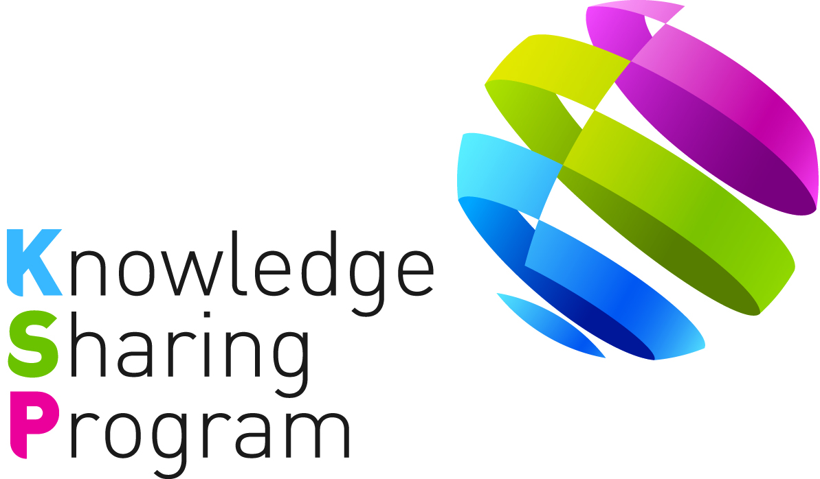

PROJECT CONCEPT PAPER
FOR
KNOWLEDGE SHARING PROJECT

-JOINT CONSULTING WITH IOs -

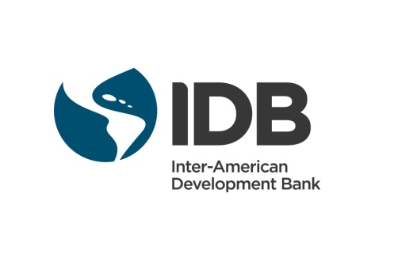

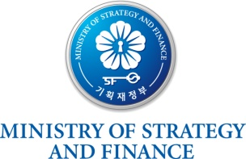
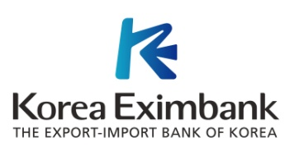
TABLE OF CONTENTS

I. Introduction 1
II. Key Issues 1
III. Project Overview 2
A. Impact 2
B. Outcome 2
C. Outputs 2
D. Activities 2
IV. Project Implementation Arrangements 4
A. Stakeholders 4
B. Work Division 4
C. Expected Schedule 5
D. Financing Plan 6
<Attachment 1> 7
<Attachment 2> 8
<Attachment 3> 10

<Project concept paper for the KSP-IDB Joint Consulting project>

Improvement of Public Investment Management in El Salvador

Date: July 28, 2016

- Introduction

- In 2004, the Ministry of Strategy and Finance of Korea (“MoSF”) launched the Knowledge Sharing Program (“KSP”) and in 2011, the MoSF newly initiated the Joint Consulting with International Organizations (“IOs”) in order to provide more tailored solutions for development partner countries by leveraging regional expertise and networks established by the IOs.

- According to the Memorandum of Understanding (“MOU”) on the KSP, duly signed on April 09, 2016, between the Inter-American Development Bank (“IDB”) and the MoSF, the IDB and the Export-Import bank of Korea (“Korea EXIMbank”), as the Government Agency for KSP, jointly prepared the following project, namely ‘Improvement of Public Investment Management in El Salvador.’ The impact, outcome, outputs, activities, implementation arrangements, and financing plans are based on consultations with the IDB and Government of El Salvador (“GoES”).

- Key Issues

- According to the International Monetary Fund (“IMF”), the economy of El Salvador is recovering slowly from the 2009 financial crisis, and GDP growth has averaged 2 percent from 2010 to 2014, well below the Central America region average of 4.5 percent. This sluggish growth is due mainly to low domestic investment and competitiveness. Also, the public debt of El Salvador is projected to rise to above 70 percent of GDP by 2021, and it is considered as a critical issue related to El Salvador’s fiscal risk. To overcome the current economic recession and increase GDP growth, El Salvadoran government has made progress in structuring a national development plan aimed at implementation public investment projects that contribute to increase economic growth.

- IDB´s Fiscal and Municipal Management Division (“IFD/FMM”) is interested in the development and modernization of public investment system in Latin America and Caribbean (“LAC”) region. In 2015, IFD/FMM carried out the project “Modernization of Public Financial Management System at the Sub-national Level (RG-T2635)”, which supports LAC countries to identify challenges of public financial management and recommend improvements. In line with this activity, IDB decided to support El Salvador to improve its public investment management system through KSP-IDB joint consulting project.

- Korea is a pioneer country in implementing the public investment management system. After the financial crisis from 1997 to 1998, Korean government undertook many steps to mitigate its challenges and revitalize its economy. Korean government also made policy changes on public investment management. Korea government has engaged with Korean Development Institute (“KDI”) as a leading think tank in public policy in Korea for technical inputs and evaluations at various stages of public investment management process, and in 2000, KDI has opened the Public Investment Management Center (“PIMAC”) for managing public investment efficiently and effectively.

- To share Korea’s best practices in more depth, the Korea EXIMbank and IDB with GoES agreed to conduct the KSP Joint Consulting Project on improving public investment management system in El Salvador. This project will help El Salvador to contribute to the successful implementation of El Salvador’s national development plan. The Korea EXIMbank will prepare and implement the Project in active cooperation with the IDB.

- Project Overview

- Impact

- The KSP-IDB Joint Consulting Project aims to implement public investment efficiently to increase the economic growth of El Salvador.

- Outcome

- The outcome of the Project is the recommendations and execution of key prioritized activities contributing to the successful implementation of El Salvador’s national development plan.

- Outputs

- The outputs of the project will be (i) Diagnostic study on the current situation and cycle of public investment in El Salvador, (ii) Case study on Korean best practices and lessons on public investment system, (iii) Comparative analysis between Korean Experience and El Salvador, (iv) Policy recommendations to execute key prioritized activities of public investment management, (v) Capacity Building Workshop, and (vi) Final Dissemination seminar.

- Activities

The following activities are expected to be conducted:

- (Activity 1) Conducting diagnostic study on the current situation in El Salvador: The KSP team will analyze the current situation of El Salvador´s public investment cycle and management mainly through document review, and on-site interviews with government officials and stakeholders. The study will include, but not limited to, (i) planning, (ii) pre-investment, and (iii) investment and project evaluation of public investment system in El Salvador. Among these phases of the project cycle, there will be a special focus on pre-investment, which is under the responsibility of the General Directorate of Credit and Public Investment, within the Ministry of Finance. Some of the key prioritized topics are: (i) Technological development of the new public investment information system and its integration with other public financial management systems; (ii) guidelines for project prioritization, sectorial project design, project monitoring and evaluation, incorporation of climate change and risk management in project formulation, definition of the social discount rate and its update methodology; (iii) promotion strategy of the new public investment system; and (iv) strategy to conduct training on public investment to the specialists at the Ministry of Finance and to other public employees involved in public investment across the national administration.

- (Activity 2) Conducting case study on Korean best practices and lessons on its public investment system: The study will methodologically review Korea’s experience and knowledge of establishing and developing public investment systems so that El Salvador could benchmark Korean best practice. Also, this activity will provide good practices and lessons learned from other public investment systems in LAC and developed countries, if needed, with focus on pre-investment. The KSP will provide the results of this activity to El Salvador through surveys and co-operation from relevant institutions.

- (Activity 3) Conducting comparative analysis between Korea and El Salvador: The study will compare the public investment system between Korean and El Salvador based on the results obtained from Activities 1 and 2. The study will include the following contents of El Salvador: (i) the institutional and organizational status and to what level and extent they have been developed and applied, (ii) the budget or investment plan for restructuring the public investment system, and (iii) the level and extent of co-operation among different agencies regarding the study.

- (Activity 4) Providing policy recommendations to execute key prioritized activities of public investment management: The KSP team will provide detailed policy recommendations to execute key prioritized activities of overall public investment management in El Salvador to contribute to the successful implementation of El Salvador’s national development plan, based on the results obtained from Activities 1, 2 & 3.

- (Activity 5) Holding Capacity Building Workshop: The KSP will come up with the agenda for the capacity building workshop with a focus on Korean knowledge and experience in development of the public investment management in Korea. The capacity building workshop program will also include lectures by Korean experts, site visits and meetings with Korean government authorities and company representatives. The KSP team will progressively cooperate with Korean experts of the concerned field and reflect their opinions into the agenda, which will be finalized in coordination with the IDB.

Upon the finalized agenda, the KSP will jointly host a capacity building workshop with the IDB, around March 2017. The IDB, with an outstanding international network, will engage some of the best qualified experts who are capable of sharing knowledge earned from international best practices.

The Workshop will last for more or less 5 days [TBD]. The details of the workshop will be determined through consultations between the KSP and the IDB.

- (Activity 6) Holding of Final Dissemination Seminar: The dissemination seminar will be held to share results of the project in El Salvador. The seminar aims to disseminate the project outputs for the national and local stakeholders.

- Project Implementation Arrangements

- Stakeholders

- The Korea EXIMbank will be in charge of the management of the Project in close collaboration with the IDB and GoES. The Korea EXIMbank will employ KSP consultants and a team of a consultant firm. The selection and engagement of consultants will be carried out based on the provisions agreed in the Terms of Reference (“ToR”) for KSP consultants among the KSP, the IDB and GoES. The following staffs of each party will lead the organization and management of the activities:

- Korea EXIMbank: Ms. Donghee Yoo , Project Team Leader
(donghee.yoo@koreaexim.go.kr, +82-2-6255-5652)
Ms. Sunjae Lee, Project Officer
(sunjae7@koreaexim.go.kr, +82-2-6255-5655)
- IDB : Mr. Axel Radics, Fiscal and Municipal Development Specialist
(axelradics@iadb.org)
Mr. Huascar Equino, Lead Fiscal and Municipal Development Specialist
(huascare@iadb.org)
- GoES : Mr. Jerson Posadas, General Director of Credit and Public Investment
(jerson.posada@mh.gob.sv)
Mr. Mario Cerna, Director of the Institutional Development Unit, Ministry of Public Works (mario.cerna@mop.gob.sv)
Alberto Enriquez, Under-Secretary of Planning, Ministry of Planning and the Presidency (aenriquez@presidencia.gob.sv)

- Work Division

- The organization of activities and specific responsibilities are as follows:

Activities  (Milestones) | IDB | Korea EXIMbank (KSP Consultants) | Funding Sources
Activity 1:  Diagnostic study on the current situation and cycle of public investment in El Salvador | Support the implementation of the activity such as  - Coordinate between GoES and KSP team  - Provide relevant data and information  - Review and comment on the work by KSP | Implement the activity | Funded by KSP
Activity 2:  Case study on Korean best practices and lessons on public investment system | - Review and comment on the work by KSP | Implement the activity | Funded by KSP
Activity 3:  Comparative analysis between Korean Experience and El Salvador | Support the implementation of the activity such as  - Coordinate between GoES and KSP team  - Provide relevant data and information  - Review and comment on the work by KSP | Implement the activity | Funded by KSP
Activity 4:  Policy recommendations to execute key prioritized activities of public investment managements | - Review and comment on the work by KSP | Implement the activity | Funded by KSP
Activity 5:  Capacity Building Workshop | -Coordinate with the KSP to finalize the agenda  - Coordinate with the KSP to prepare the workshop. (e.g.) IDB staff with relevant expertise in the public investment sector participates in workshop as a speaker, identify the participants from El Salvador | - Coordinate with the IDB to finalize the agenda  - Support the logistics for workshop participants  - Invite guest speakers of the relevant field. | Funded by KSP
Activity 6:  Final Dissemination Seminar | - Coordinate with the KSP to prepare the workshop-Compose the Technical Note based on the study | - Design and deliver the seminar | Funded by KSP

- Expected Schedule

- This Joint Consulting project will be implemented from October 2016 to May 2017. The proposed implementation schedule and milestones are as follows:

Activities (Milestones) | Expected Date
Confirmation of PCP and ToR, and selection of KSP consultant | July – October 2016
Inception Workshop (Inception Report) | November 2016
Activity 1  Diagnostic study on the current situation and cycle of public investment in El Salvador | Nov-Dec 2016
Activity 2  Case study on Korean best practices and lessons on public investment system | Nov-Dec 2016
Activity 3  Comparative analysis between Korean Experience and El Salvador | Jan-Feb 2017
Activity 4  Policy recommendations to execute key prioritized activities of public investment managements | Jan- Feb 2017
Activity 5  Capacity Building Workshop | March 2017
Activity 6  Final Dissemination Workshop (Final Report) | April 2017
Project Completion Report | May 2017

- Financing Plan

- The Project is estimated to cost USD 200,000 of which all will be financed on a grant basis by KSP. (The breakdown is adjustable)

<Attachment 1>: Basic Project Information
<Attachment 2>: Project Design and Monitoring Framework
<Attachment 3>: Outline ToR for KSP consultant

<Attachment 1>

Basic Project Information

Project Title: | Improvement of Public Investment Management in El Salvador
Project Type: | Joint Consulting (with the IDB)
Project Duration: | October 2016 – May 2017 (8 months)
Project Budget: | USD 200,000 (KSP: 200,000, IDB: [TBD])
Stakeholders: | Korea EXIMbank, IDB, GoES
Person in Charge: | - Korea EXIMbank: Ms. Yoo, Donghee (Project Team Leader),  Ms. Lee, Sunjae (Project Officer)  - IDB: Mr. Radics, Axel (Fiscal & Municipal Management Specialist)  Mr. Eguino, Huascar (Lead Fiscal & Municipal Management Specialist)  - GoES: Mr. Jerson Posadas, General Director of Credit and Public Investment  Mr. Mario Cerna, Director of the Institutional Development Unit, Ministry of Public Works  Alberto Enriquez, Under-Secretary of Planning, Ministry of Planning and the Presidency
Project Activities | Activity 1:  - Diagnostic study on the current situation and cycle of public investment in El Salvador  Activity 2:  - Case study on Korean best practices and lessons on public investment system  Activity 3:  - Comparative analysis between Korean Experience and El Salvador  Activity 4:  - Policy recommendations to execute key prioritized activities of public investment managements  Activity 5:  - Capacity Building Workshop  Activity 6:  - Final Dissemination Seminar

<Attachment 2>

Project Design and Monitoring Framework

Design Summary | Target/ Indicators | Data Sources/ Reporting Mechanisms | Assumptions/ Risks
Impact:  Implementation of public investments efficiently to increase the economic growth of El Salvador. | - The rate of GDP increased by X% in Y years from the year of the study application  - The public dept decreased by X% in Y years from the year of the study application | -Relevant Official report and statistics published by the GoES | A: Partner countries’ commitment to develop and improve public investment management
Outcomes:  The recommendations and executions of key prioritized activities contributing to the successful implementation of El Salvador’s national development plan | - Recommended key prioritized activities of public investment management through KSP project have been applied to El Salvador’s National Development Plan successfully | - Policy dialogue between El Salvador and Korea government-IDB  - El Salvador annual report or statistical publication regarding public investment | A: Partner countries’ acceptance of the recommendations provided by the KSP-IDB Joint Consulting project  R: Lack of resources for the initial set up/ data maintenance and time consuming work
Outputs:  1. Diagnostic study on the current situation and cycle of public investment in El Salvador  2. Case study on Korean best practices and lessons on public investment system  3. Comparative analysis between Korean Experience and El Salvador  4. Policy recommendations to execute key prioritized activities of public investment managements  5. Capacity Building Workshop  6. Final Dissemination Seminar | - Recommendation of improving public investment management is designed and established by 2017  - Capacity Building Workshop  - Completion of the Final Report by the early of 2017 | - Project Inception Report  - Project Interim Report  - Project Final Report  - PPMR(Project Performance Monitoring Report) & PCR (Project Completion report) | A: Active and cooperative stakeholders  R: Discordance in project timeframe between IDB and KSP;  Delay of the project
Activities with Milestones:  1. Confirmation of PCP and ToR (Jul 2016)  2. Selection of KSP consultants (Oct 2016)  3. Inception workshop (inception report) (Nov 2016)  4. Interim report  5. Capacity building workshop (Mar 2017)  6. Final report (Apr 2017)  7. Dissemination seminar (Apr 2017) |  | Inputs:  KSP: USD 200,000  IDB: [TBD]
Note:
- IDB will provide staff with relevant expertise and sector knowledge to support the implementation of the study.

- GoES will provide logistics, staff for consultation, documents, and previous studies.

<Attachment 3>

Terms of Reference

Improvement of Public Investment Management in El Salvador

- Introduction

1. The consultants’ support is required to conduct activities in accordance with key milestones and produce required outputs/outcomes described in the Project Concept Paper for the project, Improvement of Public Investment Management in El Salvador, thereby covering all scope of work and having major events such as workshops.

2. To ensure effective assistance to the Korea EXIMbank and the IDB, the consultants will be required to (i) work and liaise directly with the Korea EXIMbank, (ii) ensure good coordination with the IDB project team, and (iii) keep the Korea EXIMbank informed of all developments in a timely manner. The assignments are subject to change in agreement with the Korea EXIMbank and the IDB.

- Detailed Tasks

4. Following activities will be conducted by KSP consultant:

- Conducting diagnostic study on the current situation in El Salvador: The KSP team will analyze the current situation of public investment’s cycle and management in El Salvador mainly through the documents, and on-site interviews with government officials and stakeholders. The study will include, but not limited to, (i) planning, (ii) pre-investment, and (iii) investment and project evaluation of public investment system in El Salvador. Among these phases of the project cycle, there will be a special focus on pre-investment, which is under the responsibility of the General Directorate of Credit and Public Investment, within the Ministry of Finance. Some of the key prioritized topics are: (i) Technological development of the new public investment information system and its integration with other public financial management systems; (ii) guidelines for project prioritization, sectorial project design, project monitoring and evaluation, incorporation of climate change and risk management in project formulation, definition of the social discount rate and its update methodology; (iii) promotion strategy of the new public investment system; and (iv) strategy to conduct training on public investment to the specialists at the Ministry of Finance and to other public employees involved in public investment across the national administration.

- Conducting case study on Korean best practices and lessons on public investment system: The study will methodologically review Korea’s experience and knowledge of establishing and developing public investment system so that El Salvador could benchmark Korean best practice. Also, this activity will provide good practices and lessons learned from other public investment system in LAC and developed countries, if needed. The KSP will provide the result of this activity to El Salvador’s through the survey and co-operations from relevant institutions.

- Conducting comparative analysis between Korean and El Salvador: The study will compare the public investment system between Korean and El Salvador based on the results obtained from the Activity 1 and 2. The study will include following contents of El Salvador: (i) the institutional and organizational status and in what level and extent that the study has been developed and applied, (ii) the budget or investment plan for restructuring public investment system, and (iii) the level and extent of co-operation among different agencies regarding the study

- Providing policy recommendations to execute key prioritized activities of public investment managements: The KSP team will provide detailed policy recommendations to execute of key prioritized activities of overall public investment managements in El Salvador to contribute to the successful implementation of the El Salvador’s national development plan, based on the results obtained from the Activity 1, 2 & 3.

- Holding of Capacity Building Workshop: The KSP will come up with the agenda for the capacity building workshop with a focus on Korean knowledge and experience in development of the public investment managements in Korea. The capacity building workshop program will also include lectures by Korean experts, site visits and meetings with Korean government authorities and company representatives. The KSP team will progressively cooperate with Korean experts of the concerned field and reflect their opinions into the agenda, which will be finalized in coordination with the IDB.

- Holding of Final Dissemination Seminar: The dissemination seminar will be held to share results of the project in the IDB HQ, Korea, or El Salvador. The seminar aims to disseminate the project outputs for the national and local stakeholders, experts of concerned near future

- Outputs/Deliverables and timeline

5. The following outputs/deliverables are expected in a designated schedule:

- Inception Report (November 2016)
- Interim Report
- Capacity Building Workshop (March 2017)
- Final Dissemination Seminar (April 2017)
- Final Report (April 2017)
- Project Completion Report (May 2017)

*Please note that the estimated schedule indicated above may be subject to change.

- Costs & Estimated Financial Plan

6. The KSP budget for this assignment is USD 200,000. It will cover expenses for all the activities mentioned above, including travel and accommodation expenses for consultants and administration.

- Consultancy Requirements

- Characteristics

- The Consultant will be a Korean firm
- Contract Duration: October 2016 - May 2017
- Place(s) of work: Based in Korea, with several missions to El Salvador and the IDB HQ when necessary

- Qualifications

- Extensive experience and proven track records in developing public investment system
- Experience in reinforcing capabilities of public investment in practice will be highly preferred
- In-depth knowledge in laws and regulations associated to the public investment development
- Considering the given-time constraint and corresponding work schedule, a consulting firm should present its plan and methodology how to effectively conduct researches
- Demonstrate ability to work harmoniously with government and international officials
- Experience of cooperation with the IDB
- An excellent communication skills in English and Spanish is essential

