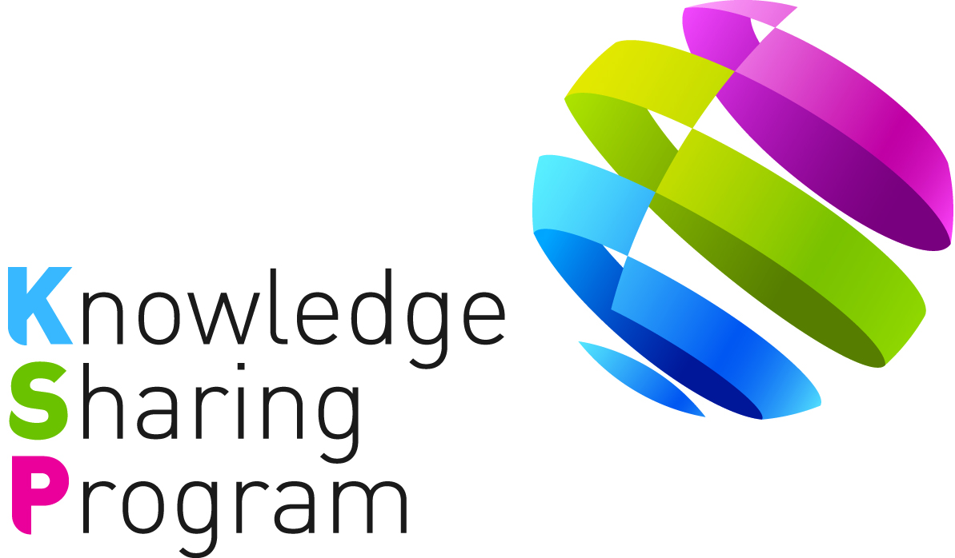

PROJECT CONCEPT PAPER
FOR
KNOWLEDGE SHARING PROGRAM

- JOINT CONSULTING WITH IOs -

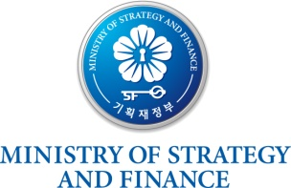
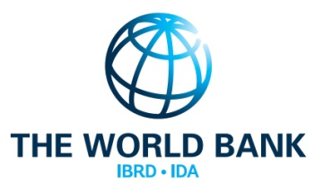
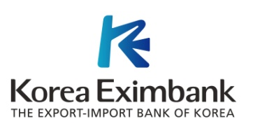

TABLE OF CONTENTS
I. Introduction 1
II. Key Issues 1
III. Project Overview 2
A. Impact & Outcome 2
B. Outputs 3
C. Activities 3
IV. Project Implementation Arrangement 4
A. Stakeholders 4
B. Work Division 5
C. Expected Schedule 6
D. Financing Plan 6
<Attachment 1> 7
<Attachment 2> 8
<Attachment 3> 11

<PROJECT CONEPT PAPER FOR THE KSP-WB JOINT CONSULTING PROJECT>

Supporting Healthcare Quality Governance and Financial Management in Colombia
(Supporting Universal Health Coverage Phase III)

Date: 9 Aug 2016

- Introduction

- In 2004, the Ministry of Strategy and Finance of Korea (“MoSF”) launched the Knowledge Sharing Program (“KSP”), and in 2011, the MoSF newly initiated the Joint Consulting with International Organizations (“IOs”) in order to provide more tailored solutions for development partner countries by employing regional expertise and networks established by the IOs.

- According to the MOU on the KSP, duly signed on September 21, 2011 between the International Bank for Reconstruction and Development (“IBRD”), the International Development Association (“IDA”) (collectively, the “World Bank” or the “Bank”) and the MoSF, the World Bank (“WB”) and the Export-Import bank of Korea (“Korea EXIMbank”) as the Government Agency for KSP jointly prepared the Joint Consulting project. The impact, outcomes, outputs, activities, implementation arrangements, and financing plans of the project are based on consultation with the WB and the government of Colombia (“GoC”).

- Key Issues

- In terms of Universal Health Coverage (“UHC”), it is a catalyst for more efficient and equitable government spending on committed health system that enables all people to access health services they need without incurring financial hardship. As it is significantly considered as the single most powerful concept that embraces the whole health system, major international organizations have been trying to put rights and equity at the center of the global vision under the title of the Sustainable Development Goals (“SDGs”).

- World Bank Group (“WBG”) also has been developing global, regional, and country-level research and analytical tools and providing direct financial and technical assistance to countries on the journey to UHC. In particular, WB and KSP team jointly developed a UHC relative project under the title of “Systemic Use of Information to Improve Health Systems Governance” in 2014 as Phase I project, and Phase II project was continued under the title of the “Supporting Universal Health Coverage” in 2015.

- The Phase I project shared Korean experience of achieving UHC at the national level and the utilization of Information and Communications Technologies (“ICT”) in health systems governance. In connection with the study results of the Phase I project, the Phase II project delivered the consulting outcome and improvement measures for Peruvian health insurance system based on Korean healthcare system and its purchasing functional framework.

- In this regard, Korean experience with the enactment of the National Health Insurance Act in 1999 which stipulated the establishment of the Health Insurance Review & Assessment Service (“HIRA”) as an independent and exclusive organization for controlling healthcare expenditure and service quality is considered as valuable asset for achieving improved healthcare services. The Act not only allowed the establishment of a specialized organization for healthcare quality assessment, but also mandated all healthcare providers, mainly owned by the private sector, to be subject to healthcare service quality assessment by law.

- Due to this advantage of fact that Korea accomplished significant quality improvement during the last 15 years since the introduction of healthcare quality assessment in 2000, WB requested to share the experience of building healthcare quality governance in Korea through specific activities including assessment study and capacity building workshop with the elaboration of ICT systems in past two years. Particularly, the KSP report in 2015 focused on Korea’s experience of National Health Insurance (“NHI”) development and its impact on the Peruvian NHI program and this study will be continued to other partner country.

- 2016 KSP-WB project will be implemented in Colombia which insuring more than 80 percent of its population, the country provides a valuable opportunity to gather evidence on a fervently debated health policy issue. Health Insurance has introduced positive changes in Colombia as i) has improved access and utilization in both the Subsidized Regime (“SR”) and Contributory Regime (“CR”) of UHC Scheme ii) has reduced the incidence of catastrophic health spending and iii) the size of the impact tends to be larger among the more disadvantaged groups. However, despite the positive impact of health insurance, much still remains to be done in Colombia such as indicators of access and financial protection among the insured, improving the quality of health services and the more limited extent of the benefit package in the SR may explain why subsidized insurance does not offer as much financial protection as does the CR. Likewise the issue of UHC is a complex concept and encompasses many variables in Colombia and it varies in extent, duration, organization and financing.

- In order to meet the needs of Colombia which deepen and widen the range of the 2014-2015 KSP-WB projects, the Korea EXIMbank and the WB agreed to conduct the Joint Consulting Project in 2016. The Korea EXIMbank will be in charge of preparation and implementation of the Joint Consulting Project with support from the WB to facilitate the transfer of Korean expertise and knowledge to Colombia.

- Project Overview

- Impact & Outcome

- The ultimate goal of the KSP-WB Joint Consulting project is intensified achievement of UHC and the health system governance in Colombia by adopting knowledge and experience learnt from Korea’s successful cases which attained through the phase I and II projects. The outcome will be enhancement in the health systems with quality assessment, financial management and strengthened capacity of working-level officers of the health sector in Colombia.

- Outputs

- The outputs of the Joint Consulting project are as follows: (i) In-depth analysis of successful Korean healthcare quality governance (healthcare quality assessment and pharmaceutical management) and financial management system and a set of recommendations with Korean policy options which may be relevant for Colombia; (ii) Knowledge sharing activities such as Capacity Building Workshop for experts of Colombia.

- Activities

- The following activities are expected to be conducted:

(Activity 1) Provide in-depth review of the case study of Korean healthcare quality governance (healthcare quality assessment and pharmaceutical management) and financial management. For continuing 2014 and 2015 KSP-WB projects, this phase III study will concentrate on more in-depth Korean experience in building healthcare quality governance and financial management. Based on the dimensions those were analyzed in the phase II projects in 2015 with regard to the evolution and lessons of healthcare quality governance and financial management sector, this study will conduct more logical and intense case analysis of health systems governance related areas.

(Activity 2) Provide implications of Korean cases to Colombian case of healthcare quality governance and financial management. Korean experiences of improving healthcare quality governance and financial management as well as overall healthcare systems will be discussed for the purpose of providing implications to Colombia’s healthcare quality governance.

Colombia has a quite a highly segmented and fragmented national health system that contributes to inequitable health outcomes. To reform this, the GoC initiated a Primary Health Care (“PHC”) strategy in 2004 which can improve health care access, population health status and health care governance controlling for socioeconomic variables. PHC strategy is considered effective in improving accessibility and utilization of services, address the social determinants of health inequities and improve health outcomes by the implementation of comprehensive interventions through sector and inter-sector collaboration, empowerment of individuals, social mobilization and community participation. This simplified and limited conception of PHC in the official health plans in the 1980s within the old National Health System (“NHS”), however, was restructured into the current General System of Social Security in Health (“GSSSH”) by creating a health system based on insurance markets with different public-private provider combinations. Colombian health system also needs to establish better information system such as national health accounts to ensure transparent financial flow and to improve inefficiencies in resource allocation in health sector.

Through this health sector reform in Colombia, the government established expectations for the competence of healthcare providers and institutions and for the quality of services they provide. In this regard, this project will compose the comparative study on comparing healthcare quality governances and financial management between Korean and Colombian cases, and provide analytical implications to Colombia based upon successful Korean case.

(Activity 3) Organize a Capacity Building Workshop for Colombia in the area of healthcare quality governance and financial management. In reference to the results delivered from studies conducted by the WB and the Korea EXIMbank, the Korea EXIMbank will come up with the agenda for the Capacity Building Workshop with a focus on Korean knowledge and experience.

The Korea EXIMbank will progressively collaborate with Korean experts and reflect their opinions into the agenda. The workshop agenda will be finalized in coordination with the WB.
Upon the finalized agenda, the Korea EXIMbank will jointly host a Capacity Building Workshop with the WB with an outstanding international network; will engage the best qualified experts who are capable of sharing knowledge earned from international and Korean best practices. The workshop will last for more or less 5 days [TBD] in Seoul, Korea. More details of the workshop will be determined through consultations between the WB and the Korea EXIMbank.

(Activity 4) Hold a final dissemination seminar. In reference to the results delivered from studies conducted by the above activities, the Korea EXIMbank will come up with the agenda for the final dissemination seminar with WB and the authorities from Colombia.

Note: All the activities above are aimed at being aligned with “the Working Plan between Colombian Ministry of Health and Social Protection and Korean Ministry of Health and Welfare.” In addition, upon request from Colombian Ministry of Health and Social Protection, the scope and depth of activities could be accordingly changed.

- Project Implementation Arrangement

- Stakeholders

- The Korea EXIMbank will be in charge of the management of the Joint Consulting project activities in close collaboration with the WB. The Korea EXIMbank will employ KSP consultants for knowledge sharing of Korean experiences. The selection and engagement of consultants will be carried out in line with the agreement on the Terms of Reference (“ToR”) for consultants between the Korea EXIMbank and the WB. The following staffs of each party will lead the organization and management of the activities:

- Korea EXIMbank:
  - Ms. Kee Young Lee (Project Team Leader, KSP Team): darim@koreaexim.go.kr
  - Mr. Sang Hak Jeon (Senior Loan Officer, KSP Team): jsh@koreaexim.go.kr
  - Ms. Jin Ju Hong (Project Officer, KSP Team): jinju1085@koreaexim.go.kr

- WB
  - Dr. Sanggon Na (Senior Technical Specialist, GHNDR): sna2@worldbank.org
  - Dr. Roberto F. Iunes (Senior Economist, GHNDR) : riunes@worldbank.org
  - Hyunki Min (Consultant, GHNDR): hkmin0122@naver.com

- Align Ministry of Colombia: Ministry of Health and Social Protection (MINSALUD)

- Work Division

- The organization of activities and specific responsibilities are as follows:
Activities | WB | Korea EXIMbank (KSP Consultants) | Funding Source
Activity 1:  Provide in-depth review of the case study of Korean health services quality governance and financial management system | Provide feedback and comments on the report, if necessary | Conduct a study | To be funded by the Korea EXIMbank;  WB components will be covered by the WB
Activity 2:  Provide implications of Korean cases to Colombian case of healthcare quality governance and financial management | Provide feedback and comments on the report, if necessary | Conduct a study | To be funded by the Korea EXIMbank;  WB components will be covered by the WB
Activity 3:  Organize a Capacity Building Workshop for Colombia in the area of healthcare quality governance and financial management | Coordinate with the  Korea EXIMbank to finalize the Capacity Building Workshop agenda;  Conduct a demand survey for the selection of the participants to the workshop; | Design the agenda for the workshop;  Arrange the Capacity Building Workshop;  Support the logistics for Korean guest speakers and workshop participants; | To be funded by the Korea EXIMbank;  WB components will be covered by the WB
Activity 4:  Hold a final dissemination seminar | Co-host the final dissemination seminar | Host the final dissemination seminar | To be funded by the Korea EXIMbank;  WB components will be covered by the WB

- Expected Schedule

- This Joint Consulting project will be implemented from August 2016 to May 2017. The proposed implementation schedule and milestones are as follows:

Activities (Milestones) | Expected Date
Consultation on the project contents with the WB | August 2016
Confirmation of PCP and ToR and Selection of KSP consultants | September 2016
Inception Workshop (Inception Report) | October 2016
Activity 1  Provide in-depth review of the case study of Korean health services quality governance and financial management system | November 2016
Activity 2 (Interim Report)  Provide implications of Korean cases to Colombian case of healthcare quality governance and financial management | February 2016
Activity 3  Organize a Capacity Building Workshop for Colombia in the area of healthcare quality | March 2017
Activity 4  Hold a final dissemination seminar (Final Report) | May 2017

- Financing Plan

- The total budget for this assignment is USD 500,000. The budget contribution from the Korea EXIMbank (KSP) is USD 250,000.

Expenditure |  | Budget (USD)
KSP Contribution |  | 250,000
 | Personnel | 70,000
 | Travel, Meeting & Workshops | 130,000
 | Miscellaneous | 50,000
The World Bank Contribution  (Continued project of Phase II in Peru) |  | 250,000
Total |  | 500,000

<Attachment 1>: Basic Project Information
<Attachment 2>: Project Design and Monitoring Framework
<Attachment 3>: ToR for KSP consultants

<Attachment 1>

Basic Project Information

Project Title: | Supporting Healthcare Quality Governance and Financial Management in Colombia (Supporting Universal Health Coverage: Phase III)
Project Type: | Joint Consulting (with the WB)
Project Duration: | August 2016 – May 2017 (8 months)
Project Budget: | USD 500,000 (KSP: 250,000, WB: 250,000)
Stakeholders: | Korea EXIMbank, The World Bank, and GoC
Person in Charge: | Korea EXIMbank: Kee Young Lee (Project Team Leader),  Sang Hak Jeon (Senior Loan Officer),  Jin Ju Hong (Project Officer), KSP Team  WB: Dr. Sanggon Na (Senior Technical Specialist),  Dr. Roberto F. Iunes (Senior Economist),  Hyunki Min (Consultant)  Align ministry from Colombia: Ministry of Health and Social Protection (MINSALUD)
Project Activities | Activity 1:  Provide in-depth review of the case study of Korean health services quality governance and financial management policies  Activity 2:  Provide implications of Korean cases to Colombian case of healthcare quality governance and financial management  Activity 3:  Organize a Capacity Building Workshop for Colombia in the area of healthcare quality governance and financial management  Activity 4:  Hold a final dissemination seminar

<Attachment 2>

Project Design and Monitoring Framework

Design Summary | Target/ Indicators | Data Sources/ Reporting Mechanisms | Assumptions/ Risks
Impact:  Intensified the achievement of UHC and the health system governance in Colombia by adopting knowledge and experience learnt from Korea’s successful cases which attained through the phase I,II and III projects. | - Strengthen the achievement of UHC based on the consulting services in Phase I, II, and III projects. | - Policy dialogue between Colombia government and Korean government/WB  - WHO annual report  - Phase I, II projects | A: Colombia’s commitment to healthcare performance improvement  R: Technical or political difficulties in collecting proper healthcare data
Outcomes:  Enhancement in the health systems with quality governance, financial management and strengthened capacity of working-level officers of the health sector in Colombia. | - Development of healthcare quality indicators based on the priority setting studies of quality assessment  - Establishment of foundation on National Health Accounts of Colombian Superintendence and Ministry of Health for transparent financial flow | - Policy dialogue between Colombia and Korean government/WB | A: Positive review of the Korean case studies and acceptance of the recommendations provided by the KSP-WB  R: Lack of resources for the initial set up
Outputs:  1. Provide in-depth review of the case study of Korean health services quality governance and financial management system  2. Provide implications of Korean cases to Colombian case of healthcare quality governance and financial management  3. Organize a Capacity Building Workshop for Colombia in the area of healthcare quality governance and financial management  4. Hold a final dissemination seminar | - Completion of the Final Report including Korean case studies by the end of 2016  - Holding of a Capacity Building Workshop in Korea by the end of 2016 | - Project Inception Report  - Project Interim Report  - Project Final Report  - PPMR (Project Performance Monitoring Report) & PCR (Project Completion Report) | A: Active and cooperative stakeholders  R: Discordance in project timeframe between the WB and the KSP;  Delay of the project
Activities with Milestones:  1. Confirmation of PCP & ToR (August 2016)  2. Selection of KSP consultants  (September 2016)  3. Inception Workshop and Inception Report (October 2016)  4. Provide in-depth review of the case study of Korean health services quality assessment and financial management policies (Activity 1) (November 2016)  5. Analyze Korean experiences of building healthcare quality assessment, and provide its implications to Colombian case of healthcare quality governance and financial management (Activity 2) (February 2017)  6. Organize a Capacity Building Workshop for Colombia in the area of healthcare quality  (Activity 3) (March2017)  7. Dissemination Seminar and Final Report (May 2017) |  | Inputs:  KSP: USD 250,000  WB: USD 250,000
 |  | Note: GoC will provide counterpart support in the form of staff, reports, documents, and other in-kind contributions

<Attachment 3>

Terms of Reference for KSP Consultants

Supporting Healthcare Quality Governance and Financial Management in Colombia
(Supporting Universal Health Coverage Phase III)

- Introduction

- The consultants’ support is required to conduct activities in accordance with key milestones and produce required outputs/outcomes described in the Project Concept Paper for the project, “Supporting Healthcare Quality Governance and Financial Management in Colombia (Supporting Universal Health Coverage Phase III)”, thereby covering all scope of work and having major events such as meetings or workshops.

- To ensure effective assistance to the Korea EXIMbank and the WB, the consultants will be required to (i) work and liaise directly with the Korea EXIMbank, (ii) ensure good coordination with the WB project team, and (iii) keep the Korea EXIMbank informed of all developments in a timely manner. The assignments are subject to change in agreement with the Korea EXIMbank and the WB.

- Detailed Tasks

- The KSP consultants, under the supervision of the Korea EXIMbank, will assist the project in Colombia by undertaking the following activities described in the Project Concept Paper:
  - Provide in-depth review of the case study of Korean healthcare quality governance and financial management
  - Provide implications of Korean cases to Colombian case of healthcare quality governance and financial management
  - Organize a Capacity Building Workshop
  - Hold a final dissemination seminar

- As a starting point of the project, an inception workshop will be organized by KSP consultants, under the supervision of the Korea EXIMbank, together with the WB project team and the project partners. From this workshop, the Korea EXIMbank and the KSP consultants will redefine and confirm assignments of the consultants in agreement with the WB and the government of Colombia.

- Outputs/Deliverables and Duration of Assignment

- The following outputs/deliverables are expected in a designated schedule:
- Inception Report (October 2016)
- Provide in-depth review of the Korean healthcare system focused on quality governance and financial management (November 2016)
- Interim Report (February 2017)
- Provide implications of Korean cases to Colombian case of healthcare quality governance and financial management (February 2017)
- Capacity Building Workshop (March 2017)
- Dissemination Seminar at Colombia (May 2017)
- Final Report and Project Completion Report (May 2017)

*Please note that the estimated schedule indicated above may be subject to change.

- Costs & Estimated Financial Plan

- The KSP budget for this assignment is USD 250,000. It will cover expenses for all the activities mentioned above, including travel and accommodation expenses for consultants and administration.

- Consultancy Requirements

- Characteristics

- The Consultant will be a Korean firm
- Contract Duration : September 2016 –April 2017
- Place(s) of work: Based in Korea, with several missions to Colombia, and the WB HQ when necessary

- Qualifications

- Extensive experience of consulting services in the issue of improving health systems performance in terms of healthcare quality
- Experience of being involved in any specific case of developing (improving) health systems governance with healthcare quality in developing countries and the understanding of contributing factors to a success will be highly weighted
- Experience in other developing countries with diverse international projects will be highly preferred
- Previous joint work experience with the World Bank, in particular a track record of research contracts with the World Bank, will be preferred
- In-depth knowledge on healthcare quality including indicator development and quality-based payment system design
- Considering the given-time constraint and corresponding work schedule, a consulting firm should present its plan and methodology how to effectively conduct researches
- Excellent communication skill in English is essential and Spanish-speaking & writing ability will be an asset

