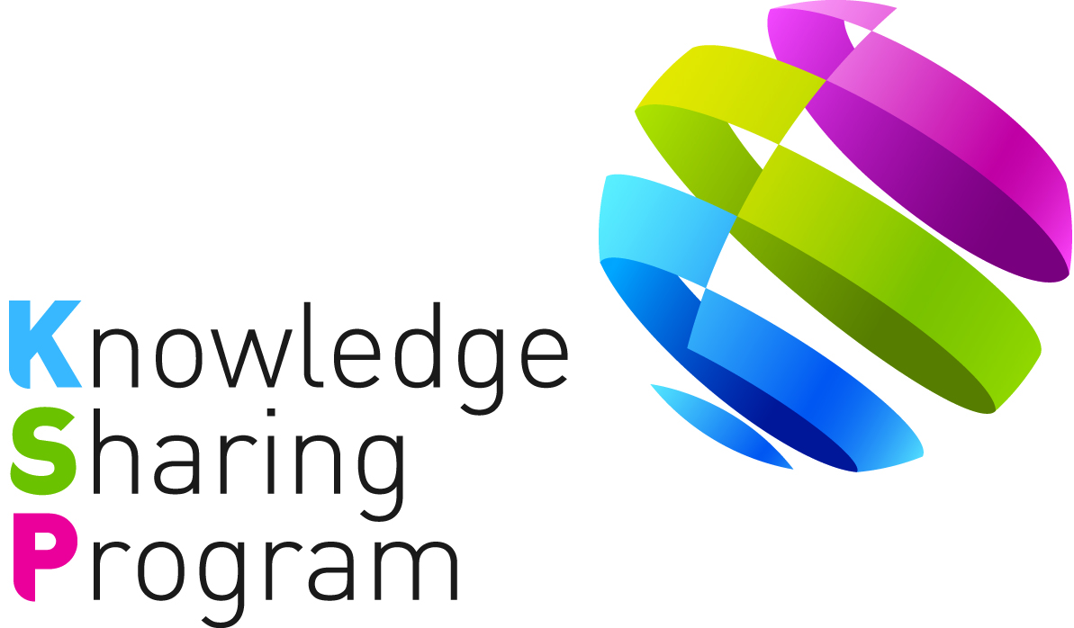

PROJECT CONCEPT PAPER
FOR
KNOWLEDGE SHARING PROJECT

-JOINT CONSULTING WITH IOs -

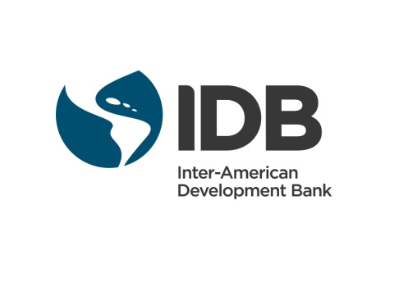

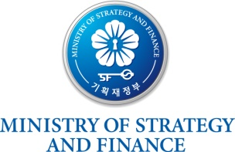

TABLE OF CONTENTS

I. Introduction 1
II. Key Issues 1
III. Project Overview 2
A. Impact 2
B. Outcome 3
C. Outputs 3
D. Activities 3
IV. Project Implementation Arrangements 4
A. Stakeholders 4
B. Work Division 5
C. Expected Schedule 6
D. Financing Plan 6
<Attachment 1> 8
<Attachment 2> 9
<Attachment 3> 11

<Project concept paper for the KSP-IDB Joint Consulting project>

Strengthening and Scaling-up Capacities of National Innovation System in Paraguay

Date: July 08, 2016

- Introduction

- In 2004, the Ministry of Strategy and Finance of Korea (“MoSF”) launched the Knowledge Sharing Program (“KSP”) and in 2011, the MoSF newly initiated the Joint Consulting with International Organizations (“IOs”) in order to provide more tailored solutions for development partner countries by leveraging regional expertise and networks established by the IOs.

- According to the Memorandum of Understanding (“MOU”) on the KSP, duly signed on April 09, 2016, between the Inter-American Development Bank (“IDB”) and the MoSF, the IDB and the Export-Import bank of Korea (“Korea EXIMbank”), as the Government Agency for KSP, jointly prepared the following project. The impact, outcome, outputs, activities, implementation arrangements, and financing plans are based on consultations with the IDB and Government of Paraguay (“GoP”).

- Key Issues

- In the last decade, Paraguay has been one of the fastest growing economies in Latin America and Caribbean region (“LAC”). However, the high poverty, inequality rates, corruption, and lack of investment in knowledge remain the biggest challenges that the country has to face in order to reach its growth potential. To solve the problem of lack of investment in knowledge, Paraguay has gradually set up a system of rules, institutions, and other policy instruments to ensure the coordination of the country’s science, technology, and innovation activities, through the implementation of Science, Technology and Innovation (“STI”) via National Funding Agencies (“NFAs”) and Government-funded Research Institutes (“GRIs”). However, because of the relatively late establishments of those NFAs and GRIs compared to other LAC, Paraguay lags well behind many of its LAC counterparts when it comes to R&D spending. On average, Paraguay invests 0.06 percent of the gross domestic product in R&D, while the average for the LAC region is between 0.5 and 0.6 percent, and for developed countries between 2.5 and 3 percent of the GDP. In 2012, Luis Alberto Davalos, the former president of the National Council of Science and Technology (“CONACYT”), said that Paraguay needs to devote increased investment to the field of science and technology to stop being dependent on other countries.

- In Paraguay, CONACYT, the NFA, is in charge of the management, coordination and evaluation of the national system of STI. CONACYT is composed of representatives from various ministries, industrial associations, state and private universities, trade unions, and the Scientific Society. For the development of Paraguay’s STI, IDB approved of a $6.5 million loan for a program supporting the ‘Development of Science, Technology and Innovation (PR0126)’ in 2005, and CONACYT was in charge of the execution of this loan program to enhance the country’s research and innovation capacity. A second loan program (PR-L1070), known as PROINNOVA for a total of $10 million was approved by the Bank in November 2015. The loan contract for this second program is pending ratification by the National Congress according to the national procedures. CONACYT will be also the executing authority of PROINNOVA. However, regardless of support from IDB, CONACYT still need to develop institutional capacities in key areas such as policy planning, information systems, human capital and program evaluation, in particular regarding to how to encourage GRIs to transfer technology to the productive sector and how to promote business innovation.

- The Korean innovation system is extensive and in many respects highly developed. That system has been one of the underpinning of Korea’s rapid industrialization. From the middle of 1960s, several GRIs were established, such as the Korea Institutes of Science and Technology. The GRIs of Korea aimed to carry out R&D in key technological fields, with a view to supporting the industrial upgrading strategy. The most of NFAs, such as Korea Institute for Advancement of Technology and National Research Foundation, were established under Article 38-1 of the Industrial Technology Innovation Promotion Act to efficiently and systematically promote industrial innovations and to support policy development in industrial technology in 2009.

- To share Korea’s best practices in more depth, the Korea EXIMbank and IDB with the GoP agreed to conduct the KSP Joint Consulting Project on improving capabilities of national innovation system in Paraguay. This project will help Paraguay to scale up their NFAs and GRIs for the development of STI, which will eventually support to raise Paraguay’s national competitiveness. The Korea EXIMbank will be in charge of preparation and implementation of the Project in active cooperation with the IDB.

- Project Overview

- Impact

- The KSP-IDB Joint Consulting Project aims to build institutional capacity of the overall national innovation system of Paraguay for raising the national competitiveness and sustainable productivity growth.

- Outcome

- The outcome of the Project is to reinforce capabilities of NFAs and GRIs for improving the effectiveness of the science and technology innovation system in Paraguay.

- Outputs

- The outputs of the project will be (i) Diagnostic study on the current situation of national innovation system and relevant institutions in Paraguay, (ii) Comprehensive overview of Korea’s national innovation system and detailed case study of key Korean NFAs and GRIs relevant for Paraguay, (iii) Capacity Building Workshop, (iv) Suggestion of preliminary feasibility study for developing and operating NFAs and GRIs in Paraguay, and (v) Final Dissemination Seminar.

- Activities

The following activities are expected to be conducted:

- (Activity 1) Diagnostic study on the current situation of national innovation system and relevant institutes in Paraguay: The KSP team will analyze the current situation of national innovation system and relevant institutes such as GRIs through existing documentation, and on-site interviews with government officials and stakeholders. The study will include, but not limited to, the technical and financial strengths, and constraints of STI in Paraguay. In addition to CONACYT, Paraguay has a cluster of 12 GRIs, one important outcome of the diagnostic study would be to validate the identification and selection of three of them in order to be later one benchmarked against peer Korean GRIs.

- (Activity 2) Comprehensive and detailed case study on Korean experience of NFAs and GRIs: The study will review Korea’s national innovation system with a particular focus on the experience and knowledge of establishing and developing NFAs and GRIs for science and technology innovation of Korea so that Paraguay could benchmark Korea’s best practice. This activity will conduct case study covering the institutional design, governance, policy planning, foresight activities, human capital activities and the overall process from funding to implementation of Korean NFAs and GRIs. KSP team will find the preliminary targets of NFA and GRI to carry out this Activity through the discussion with GoP and IDB and use the results of the diagnostic study in activity 1.

The preliminary targets of NFAs may include: National Research Foundation (NRF), Korean Institute for the Advancement of Technology (KIAT), Korean Evaluation Institute of Industrial Technology (KEIT), Korean Institute for Start-up and Entrepreneurship (KISED), and Korean Technology Guarantee Fund (KIBO)

The preliminary targets of GRIs may include: Science and Technology Policy Institute (STEPI), Korean Institute of Science and Technology (KIST), Korean Research Institute of Bioscience and Biotechnology (KRIBB), Korea Food Research Institute (KFRI) and the Electronics and Telecommunications Research Institute (ETRI). Particular attention will be given to at studying the National Research Council of Science and Technology (“NST”) as a holding agency under the Ministry of Science, Information Technology and Future Planning (MSIP) that coordinate the operation and evaluation of the different GRIs.

- (Activity 3) Capacity Building Workshop: In reference to the results delivered from the studies conducted by the KSP and the IDB, the KSP will come up with the agenda for the capacity building workshop with a focus on Korean knowledge and experience in the development science and technology innovation system and implementation of NFAs and GRIs in Korea. The capacity building workshop program will also include lectures by Korean experts, site visits and meetings with Korean government authorities and company representatives. The KSP team will progressively cooperate with Korean experts of the concerned field and reflect their opinions into the agenda, which will be finalized in coordination with the IDB.

Upon the finalized agenda, the KSP will jointly host a capacity building workshop with the IDB in Seoul, Korea, around December in 2016 or January in 2017. The IDB, with an outstanding international network, will engage the best qualified experts who are capable of sharing knowledge earned from international best practices.

The workshop will last for more or less 5 days [TBD]. The details of the workshop will be determined through consultations between the KSP and the IDB.

- (Activity 4) Macro institutional recommendations to regulate and strengthen the NFAs and GRIs in Paraguay: With the results of the Activity 1 and 2, the KSP team will propose the macro institutional recommendation to strengthen STI of Paraguay. This activity will include the general recommendations with a particular focus on the institutional reforms needed to regulate the operations of the NFAs and GRIs, and the design of an institutional peer-review methodology to assess the operation of CONACYT and GRIs.

- (Activity 5) Final Dissemination Seminar: The dissemination seminar will be held to share results of the project in the, , or Paraguay. The seminar aims to disseminate the project outputs for the national and local stakeholders, experts of concerned near future.

- Project Implementation Arrangements

- Stakeholders

- The Korea EXIMbank will be in charge of the management of the Project in close collaboration with the IDB and GoP. The Korea EXIMbank will employ KSP consultants, a team of firm consultants. The selection and engagement of consultants will be carried out based on the provisions agreed in the Terms of Reference (“ToR”) for KSP consultants among the KSP, the IDB and GoP. The following staffs of each party will lead the organization and management of the activities:

- Korea EXIMbank: Ms. Donghee Yoo, Project Team Leader
(donghee.yoo@koreaexim.go.kr, +82-2-6255-5652)
Ms. Hyeri Lee, Loan Officer
(hyeri127@koreaexim.go.kr, +82-2-6255-5674)
Ms. Sunjae Lee, Project Officer
(sunjae7@koreaexim.go.kr, +82-2-6255-5655)
- IDB: Mr. Gustavo Crespi, CTI/CUR Lead Specialist
(gcrespi@iadb.org, +598 2601 7696)
Mr. Pablo Angelelli, CTI/CHL Senior Specialist
(pabloan@iadb.org)
Ms. Gabriela Martinez, IFD/CTI Senior Operations Associate
(gabrelama@iadb.org)
Mr. Suk Nam, IFD/CMF Consultant
(sukn@iadb.org, +1-202-523-7480)
- GoP: Idelin Molinas Vega, CONACYT Executive Secretary
- Work Division

- The organization of activities and specific responsibilities are as follows:

Activities  (Milestones) | IDB | Korea EXIMbank (KSP Consultants) | Funding Sources
Activity 1:  Diagnostic study on the current situation of national innovation system and relevant institutes in Paraguay | Support the implementation of the activity such as  - Coordinate between GoP and KSP team  - Provide relevant data and information  - Review and comment on the work by KSP | Implement the activity | Funded by KSP
Activity 2:  Comprehensive and detailed case study on Korean NFAs and GRIs | - Review and comment on the work by KSP | Implement the activity | Funded by KSP
Activity 3:  Capacity Building Workshop | -Coordinate with the KSP to finalize the agenda  - Coordinate with the KSP to prepare the workshop. (e.g.) IDB staff with relevant expertise in the STI sector participates in workshop as a speaker, identify the participants from Paraguay | - Coordinate with the IDB to finalize the agenda  - Support the logistics for workshop participants  - Invite guest speakers of the relevant field. | Funded by KSP
Activity 4:  Macro institutional recommendations to regulate and strengthen the NFAs and GRIs in Paraguay | Support the implementation of the activity such as  - Coordinate between GoP and KSP team  - Provide relevant data and information  - Review and comment on the work by KSP | Implement the activity | Funded by KSP
Activity 5:  Final Dissemination Seminar | - Coordinate with the KSP to prepare the Seminar | - Design and deliver the seminar | Funded by KSP

- Expected Schedule

- This Joint Consulting project will be implemented from July 2016 to March 2017. The proposed implementation schedule and milestones are as follows:

Activities (Milestones) | Expected Date
Consultation on the project contents with the IDB | July 2016
Confirmation of PCP and ToR, and selection of KSP consultant | September 2016
Inception Workshop (Inception Report) | September 2016
Activity 1  Diagnostic study on the current situation of national innovation system and relevant institutes in Paraguay | October 2016
Activity 2  Comprehensive and detailed case study on Korean NFAs and GRIs | November - December 2016
Activity 3  Capacity Building Workshop | January 2017
Activity 4  Macro institutional recommendations to regulate and strengthen the NFAs and GRIs in Paraguay | January 2017
Activity 5  Final Dissemination Seminar (Final Report) | February 2017
Project Completion Report | March 2017

- Financing Plan

- The Project is estimated to cost USD 200,000 of which all will be financed on a grant basis by KSP. The IDB will link the results of the Project to Technical Cooperation, of which the budget will be spent on the establishment of the master plan for restructuring NFAs and GRIs to foster STI activities in Paraguay.

<Attachment 1>: Basic Project Information
<Attachment 2>: Project Design and Monitoring Framework
<Attachment3>: Outline ToR for KSP consultant (TBD)

<Attachment 1>

Basic Project Information

Project Title: | Strengthening and Scaling-up Capacities of National Innovation System in Paraguay
Project Type: | Joint Consulting (with the IDB)
Project Duration: | September 2016 – March 2017 (7 months)
Project Budget: | USD 200,000 (KSP: USD 200,000)
Stakeholders: | Korea EXIMbank, IDB, GoP
Person in Charge: | - Korea EXIMbank: Ms. Yoo, Donghee (Project Team Leader)  Ms. Lee, Hyeri (Project Team Leader)  Ms. Lee, Sunjae (Project Officer)  - IDB: Mr. Crespi, Gustavo (CTI/CUR Lead Specialist)  Mr. Angelelli, Pablo (CTI/CHL Senior Specialist)  Ms. Martinez, Gabriela (IFD/CTI)  Mr. Nam, Suk (IFD/CMF Consultant)  - GoP: Idelin Molinas Vega, Executive Secretary CONACYT
Project Activities | Activity 1:  - Diagnostic study on the current situation of national innovation system and relevant institutes in Paraguay  Activity 2:  - Comprehensive and detailed case study on Korean NFAs and GRIs  Activity 3:  - Capacity Building Workshop  Activity 4:  - Macro institutional recommendations to regulate and strengthen the NFAs and GRIs in Paraguay  Activity 5:  - Final Dissemination Seminar

<Attachment 2>

Project Design and Monitoring Framework

Design Summary | Target/ Indicators | Data Sources/ Reporting Mechanisms | Assumptions/ Risks
Impact:  Building institutional capacity in overall national innovation system in Paraguay for raising the national competitiveness | - The expenditures in R&D investment in Paraguay increased by 30% (as a proportion of the GDP) in 5 years from the year of the study application. | -Relevant Official report and statistics published by the GoP | A: Partner countries’ commitment to develop and improve the national investment innovation system
Outcomes:  Reinforcement of capabilities of NFA and GRI for improving science and technology innovation system in Paraguay | - Suggested policy recommendation for Paraguay’s national innovation system has been applied to Paraguay’s national development plan for STI | - Policy dialogue between Paraguay and Korea government-IDB  - Paraguay’s annual report or statistical publication regarding national innovation system | A: Partner countries’ acceptance of the recommendations provided by the KSP-IDB Joint Consulting project  R: Lack of resources for the initial set up/ data maintenance and time consuming work
Outputs:  1. Diagnostic study on the current situation of national innovation system and related institutes in Paraguay  2. Comprehensive and detailed case study on Korean NFAs and GRIs  3. Capacity Building Workshop  4. Macro institutional recommendations to regulate and strengthen the NFAs and GRIs in Paraguay  5. Final Dissemination Seminar | - Successful detailed case studies of Korean NFAs and GRIs  - Capacity Building Workshop  - Completion of the Final Report by the early of 2017 | - Project Inception Report  - Project Interim Report  - Project Final Report  - PPMR(Project Performance Monitoring Report) & PCR (Project Completion report) | A: Active and cooperative stakeholders  R: Discordance in project timeframe between IDB and KSP;  Delay of the project
Activities with Milestones:  1. Confirmation of PCP and ToR (Jul 2016)  2. Selection of KSP consultants (Sep 2016)  3. Inception workshop (inception report) (Sep 2016)  4. Interim report  5. Capacity building workshop (Jan 2017)  6. Final report (Feb 2017)  7. Dissemination seminar (Feb 2017) |  | Inputs:  KSP: USD 200,000  IDB: [TBD]
Note:
- IDB will provide staffs with relevant expertise and sector knowledge to support the implementation of the study.

- GoP will provide logistics, staff for consultation, documents, and previous studies.

<Attachment 3>

Terms of Reference

Strengthening and Scaling-up Capacities of National Innovation System in Paraguay

- Introduction

1. The consultants’ support is required to conduct activities in accordance with key milestones and produce required outputs/outcomes described in the Project Concept Paper for the project, Strengthening and Scaling-up Capacities of National Innovation System in Paraguay, thereby covering all scope of work and having major events such as workshops.

2. To ensure effective assistance to the Korea EXIMbank and the IDB, the consultants will be required to (i) work and liaise directly with the Korea EXIMbank, (ii) ensure good coordination with the IDB project team, and (iii) keep the Korea EXIMbank informed of all developments in a timely manner. The assignments are subject to change in agreement with the Korea EXIMbank and the IDB.

- Detailed Tasks

3. Following activities will be conducted by KSP consultant:

- Diagnostic study on the current situation of national innovation system and relevant institutes in Paraguay: The KSP team will analyze the current situation of national innovation system and relevant institutes such as GRIs through existing documentation, and on-site interviews with government officials and stakeholders. The study will include, but not limited to, the technical and financial strengths, and constraints of STI in Paraguay. In addition to CONACYT, Paraguay has a cluster of 12 GRIs, one important outcome of the diagnostic study would be to validate the identification and selection of three of them in order to be later one benchmarked against peer Korean GRIs.

- Comprehensive and detailed case study on Korean experience of NFAs and GRIs: The study will review Korea’s national innovation system with a particular focus on the experience and knowledge of establishing and developing NFAs and GRIs for science and technology innovation of Korea so that Paraguay could benchmark Korea’s best practice. This activity will conduct case study covering the institutional design, governance, policy planning, foresight activities, human capital activities and the overall process from funding to implementation of Korean NFAs and GRIs. KSP team will find the preliminary targets of NFA and GRI to carry out this Activity through the discussion with GoP and IDB and use the results of the diagnostic study in activity 1.

The preliminary targets of NFAs may include: National Research Foundation (NRF), Korean Institute for the Advancement of Technology (KIAT), Korean Evaluation Institute of Industrial Technology (KEIT), Korean Institute for Start-up and Entrepreneurship (KISED), and Korean Technology Guarantee Fund (KIBO)

The preliminary targets of GRIs may include: Science and Technology Policy Institute (STEPI), Korean Institute of Science and Technology (KIST), Korean Research Institute of Bioscience and Biotechnology (KRIBB), Korea Food Research Institute (KFRI) and the Electronics and Telecommunications Research Institute (ETRI)

- Capacity Building Workshop: In reference to the results delivered from the studies conducted by the KSP and the IDB, the KSP will come up with the agenda for the capacity building workshop with a focus on Korean knowledge and experience in the development science and technology innovation system and implementation of NFAs and GRIs in Korea. The capacity building workshop program will also include lectures by Korean experts, site visits and meetings with Korean government authorities and company representatives.

- Macro institutional recommendations to regulate and strengthen the GRIs in Paraguay: With the results of the Activity 1 and 2, the KSP team will propose the macro institutional recommendation to establish a NST to regulate the GRIs in Paraguay. This activity will include the general recommendations regarding strengthen STI of Paraguay with a particular focus on the institutional reforms needed to regulate the operations of the NFAs and GRIs, and the design of an institutional peer-review methodology to assess the operation of CONACYT and GRIs.

- Final Dissemination Seminar: Sharing the results of the project in the IDB HQ, Korea, or Paraguay. The seminar aims to disseminate the project outputs for the national and local stakeholders, experts of concerned near future.

- Outputs/Deliverables and timeline

4. The following outputs/deliverables are expected in a designated schedule:

- Inception Report (October 2016)
- Capacity Building Workshop (January 2017)
- Interim Report
- Final Dissemination Seminar (February 2017)
- Final Report (February 2017)
- Project Completion Report (March 2017)

*Please note that the estimated schedule indicated above may be subject to change.

- Costs & Estimated Financial Plan

5. The KSP budget for this assignment is USD 200,000. It will cover expenses for all the activities mentioned above, including travel and accommodation expenses for consultants and administration.

- Consultancy Requirements

- Characteristics

- The Consultant will be a Korean firm
- Contract Duration: September 2016 - March 2017 [TBD]
- Place(s) of work: Based in Korea, with several missions to Paraguay and the IDB HQ when necessary

- Qualifications

- Extensive experience and proven track records in developing national innovation system
- Experience in reinforcing capabilities of NFAs and GRIs in practice will be highly preferred
- In-depth knowledge in laws and regulations associated to the STI development
- Considering the given-time constraint and corresponding work schedule, a consulting firm should present its plan and methodology how to effectively conduct researches
- Demonstrate ability to work harmoniously with government and international officials
- Experience of cooperation with the IDB
- An excellent communication skills in English is essential and the Spanish-speaking ability will be an asset

1 For example, nowadays most of the business innovation support programs are horizontal so they support R&D independently of the sector where the R&D is being carried-out. Given the small budgets for R&D support, this leads to the fragmentation of the fiscal resources in a large set of much dispersed activities. CONACYT needs to improve its capacities for sector prioritization and focus.
2 Paraguayan Institute for Agricultural Technology (IPTA), ITAIPU Technology Park Foundation (FPTI), Institute for Tropical Medicine (ITM), National Health Institute (INS), Institute of Agriculture Biotechnology (INBIO), ITAPUA Technology Development Center (ARP), Health Sciences Research Institute (IICS), Digital Electronics Laboratory (LED), USCA Technology Development Center (CDT), San Carlos Technology Development Center (CTD), Polytechnic School (FP) and Scientific Research Development Center (CEDIC).

